Deliverable 4.5: A paper on the survey experiments, focusing on factors shaping attitudes towards liberal democracy.

# 

# Introduction

This deliverable is based on a set of conjoint experiments which investigate the sources of the normative divergence from the model of liberal democracy in Europe. The basic premise is that liberal democracy faces not one ideological challenge but many. Against that background, the experimental design systematically explores populist, illiberal and authoritarian deviations from liberal democracy. The conjoint experimental part of the project is embedded in a public opinion survey that examines citizens’ liberal and anti-liberal[1] attitudes in seven countries: France, Italy, Great Britain, Austria, Hungary, Poland and Czechia. The experiments consist of a set of party choices in which populist, illiberal and authoritarian (PIA) alternatives to liberal democracy are explored on three basic dimensions of democracy: civil liberties, rule of law, and free and fair elections.

This study reveals that European voters generally favour liberal democratic principles and penalise parties with illiberal and authoritarian positions, although they show more tolerance for populist stances. While socio-demographic characteristics play a limited role in shaping these preferences, voters' policy views, particularly on immigration, prove crucial. Most notably, while voters rarely compromise democratic principles for economic policy alignment, those opposed to immigration often support parties that match their immigration preferences regardless of these parties' democratic credentials, suggesting that immigration is a issue with a substantial capacity to undermine democratic commitments.

# Discussion of PIA

The foundational tenets of liberal democracy—political rights, pluralism, free and fair elections, and the rule of law—have historically met with substantial opposition and have yet to achieve universal legitimacy. Nonetheless, from 1945 to 2000, these principles garnered significant normative and institutional adoption on a global scale. However, recent years have witnessed significant cases of democratic backsliding in previously consolidated liberal democracies, accompanied by an ideological pushback against liberal democratic values (Alizada et al., 2021).

Today, particularly in Europe, a range of ideological and structural forces challenge the liberal democratic paradigm (Zakaria, 1997; Diamond, 2002; Levitsky & Way, 2002; Merkel, 2004; Bogaards, 2009; Erdmann, 2011; Schedler, 2015; Wodak, 2019; Enyedi, 2024). In the following analysis, we distinguish the distinct challenges posed by populism, illiberalism, and authoritarianism, which we refer to collectively as PIA. Each of these challenges is anti-liberal in character, in the sense that it constitutes a divergence from the liberal democratic model, and overlaps with the other in certain ways. Yet PIA phenomena vary in the degree and nature of their departure from liberal democratic principles. Each emerges from distinct ideological roots, follows its own developmental trajectory, and thrives under different socio-political conditions (Markowski, 2023). Furthermore, each form is shaped by different causal factors and is likely facilitated by varying socio-political contexts, underscoring the complex, context-dependent nature of anti-liberal forces.

This multifaceted opposition to liberal democracy underscores the need for an adaptive theoretical framework that can adequately distinguish among these competing models, each of which presents distinct risks to liberal democratic stability and the maintenance of democratic norms. Empirically-driven political scientists recognise the intricacy of anti-liberal democratic phenomena, encapsulated by populism, illiberalism, and authoritarianism (PIA). These alternatives to liberal democracy (ALDs) defy simple classification along conventional left-right ideological spectra, often interweaving components of broader “thick” ideologies such as nationalism, conservatism, and occasionally socialism. Extensive scholarship has examined the intersecting and divergent characteristics of these three forms of ALDs, including models that visually delineate their ideological commonalities and distinctions. Here, we present a synthesised overview of key insights.

Within the AuthLib project, we have undertaken a range of initiatives to impose conceptual coherence on the extensive and rapidly expanding literature concerning ALDs (Markowski, 2023; Markowski et al., 2023; Enyedi, 2024; Rovny et al., 2024). These initiatives include several planned project deliverables (D2.1 and D4.3) as well as academic articles authored by AuthLib participants (e.g., Pirro & Stanley, 2022). The theoretical rationale underpinning the concepts and phenomena analysed in this deliverable (D4.5) is extensively discussed in the Literature Review (D2.1) and the theoretical section of the Typology on the distribution of illiberal orientations across EU Member States (D4.3). For the purposes of this paper, we simply revisit the principal premises and operationalization of PIA—populism, illiberalism, and authoritarianism.

Our primary focus here is on citizen attitudes and preferences, particularly in terms of how individuals engage with democratic alternatives, navigate conflicting pressures, and decide on trade-offs. Recent empirical studies have shown that voters may exhibit indifference toward populist, illiberal, and authoritarian deviations from liberal democratic ideals when these deviations align with their ideological or partisan interests. Evidence indicates that, especially within polarised electorates (Svolik, 2019), citizens may prioritise partisan gains over core democratic principles, such as judicial independence, checks-and-balances mechanisms, and civil liberties, when these principles are perceived to be at odds with pressing partisan goals or ideological commitments.

In this paper we operationalise PIA both as a distinct set of stances held by political parties on liberal democracy, and also as a set of three latent attitudes exhibited to a greater or lesser extent by the electorates of the liberal democracies we examine in the AuthLib project. Information on the operationalisation of PIA can be found in Deliverable 4.3.

# Expectations and hypotheses

Several assumptions follow from the theoretical foundations laid out in the previous section and in the deliverables of WP2 (Links to Lit Review and Guidelines).[2] First, PIA divergences from liberal democracy usually follow a sequential path. Populism, in which the elites of liberal democracy are challenged initially from the position of political opposition, is the least substantial deviation from liberal democracy, in that it challenges the hegemony of current elites and the institutions they have populated but does not necessarily mandate a wholesale departure from democracy itself. Indeed, populists may, on achieving power, cease to attack the elite and instead engage in a process of elite replacement, availing themselves of the institutional protections afforded by liberal democracy while adapting their political appeals accordingly.

Illiberal and authoritarian positions represent different grades of democratic backsliding that go beyond the initial incursions made by populism. Illiberalism expands on populism’s hostility to minorities, advocating not only the pursuit of majoritarian interests but actively advocating the repression of minority interests, while remaining within a constrained and debased but still recognisably democratic institutional framework. Authoritarianism, meanwhile, advocates a political system in which accountability is fundamentally subordinated to the exercise of power, even if vestigial structural elements of a liberal democratic system remain.

Our baseline expectation is that liberal democratic positions remain normatively more accepted than PIA positions, but that the extent to which a political party is “punished” for advocating aspects of a PIA political system will vary according to how far those ideas deviate from liberal democracy.[3] Hence, we expect that while parties advocating PIA positions will be punished for their deviations from liberal democracy, this will be less the case for populist parties, while illiberal and authoritarian parties will be more likely to be penalised for such deviations. This expectation is expressed in our first set of hypotheses:

* *H1a: Parties with liberal democratic features will be more likely to be chosen than parties with populist, illiberal or authoritarian (PIA) features.*
* *H1b: Parties with populist features will be less likely to be punished for deviating from liberal democratic norms than parties with illiberal or authoritarian features.*
* *H1c: Parties with illiberal features will be less likely to be punished from deviating from liberal democratic norms than parties with authoritarian features.*

Second, there are good reasons to believe that there will be a congruence between individual-level positions on PIA attitudes and party PIA attributes. We expect that citizens with higher levels of attachment to liberal democracy, as indicated by higher scores on liberal democratic attitudes, should be more likely to punish parties with PIA features, while those with high levels of PIA attitudes are more likely to favour populism, illiberalism or authoritarianism respectively. While some studies call into question the idea that citizens who hold higher levels of populist attitudes are necessarily more likely to vote for populist parties (Neuner and Wratil, 2022), this intuitively plausible hypothesis still requires further testing, as does the equally plausible claim that those with illiberal or authoritarian attitudes are more likely to reward parties for advocating such policies. Accordingly, we formulate our second set of hypotheses as follows:

* *H2a. Citizens holding liberal democratic attitudes will be more likely to punish parties with PIA features.*
* *H2b. Citizens holding populist attitudes will be more likely to choose parties with populist features.*
* *H2c. Citizens holding illiberal attitudes will be more likely to choose parties with illiberal features.*
* *H2d. Citizens holding authoritarian attitudes will be more likely to choose parties with authoritarian features.*

Our third set of analyses is founded in the assumption that parties whose positions on questions of specific policies align with citizens’ individual preferences on those issues will be punished less for PIA deviations from liberal democracy. While support for – or opposition to – democracy may be fundamental for some voters, it may be a matter of tradeoffs for others. It is plausible that some of those who are ostensibly committed to liberal democracy may be willing to overlook a lack of commitment to those values from other political parties, if those parties offer something else they value.

Accordingly, we hypothesise that those citizens who are party-congruent – that is, they hold a position on specific policy issues which is close to or identical to that of the party whose democratic credentials they are currently evaluating – will be more likely to turn a blind eye to PIA departures from liberal democracy (Wunsch and Gessler, 2023; Svolik et al., 2023). As the connotations of “left” and “right” differ across our universe of cases, we distinguish between two dimensions of policy: economic and sociocultural.

* *H3a. Citizens will be less likely to punish parties with PIA features if the economic stances of these parties align with their own.*
* *H3b. Citizens will be less likely to punish parties with PIA features if the views on immigration of these parties align with their own.*

Finally, some studies point towards the heterogeneity of the success of PIA appeals across different social groups, with age and gender gaps identified as particularly consequential in voting for the populist radical right. The young (Zagórski et al., 2024; Foa and Munck, 2019) and males (Coffe et al., 2023; Gwiazda, 2021) have been found to support these parties to a greater degree. In line with this literature, we expect that:

* *H4a. Young citizens (<30) will be less likely than their older counterparts to punish PIA deviations from liberal democratic norms.*
* *H4b. Men will be less likely than women to punish PIA deviations from liberal democratic norms.*

# Explanation of conjoint approach

To address these hypotheses, we conducted a pre-registered conjoint survey experiment embedded in the survey of public opinion about political attitudes and behaviour that constitutes one of the deliverables of WP4. The conjoint element was placed towards the end of the survey, following questions about vote choice and prior to the set of sociodemographic questions. It consisted of nine fully-randomised forced choice tasks, in which respondents were asked to select either Party A or Party B on the basis of information about their ideological positions on various issues, as shown below in Tables 1–3.

In each case, a respondent made a decision after receiving information on three party attributes. In each case, this information included either a left-wing, a centrist, or a right-wing position on the economic issue of tax policy, and a liberal, centrist, or conservative position on the sociocultural issue of immigration. For three of the nine tasks, respondents then received information about the positions of parties on the first dimension of liberal democracy: civil liberties. The positions in question varied between a liberal-democratic position, a populist position, an illiberal position, and an authoritarian position. For three tasks, respondents were given information about party positions on the rule of law, again varying liberal, populist, illiberal and authoritarian positions. For another three tasks, respondents were provided with information about party positions on free and fair elections. This design enabled us to assess support for PIA deviations from liberal democracy on key dimensions, while taking into account both the other dimensions of democracy and preferences over important issues of policy.

The wording of each choice task was as follows: “*Imagine that there are parliamentary elections soon in [Country]. In the following, we present you with several comparisons of parties with a significant chance of winning the election. For each of these comparisons, we would like to know which of these two parties (A or B) you would vote for. Please take a close look at the descriptions of the two parties before evaluating them in the next step. The information is provided in the form of a table summarising the different postulates of each party. If you had to choose, which party would you be more likely to vote for?*”

Table 1: *Civil liberties*

|  |  |  |
| --- | --- | --- |
| Attribute | Level | Wording |
| Economic | leftwing | We will introduce high personal income taxes, collecting more from rich to fund a generous welfare state (e.g. health and educational public services) |
| centrist | We will introduce moderate personal income taxes, with the rich paying somewhat more to fund a reasonable welfare state (e.g. health and educational public services) |
| rightwing | We will introduce low personal income taxes, with everybody paying the same rate to fund a minimal welfare state (e.g. health and educational public services) |
| Cultural | “liberal” | We will accept migrants regardless of the country of origin |
| “centrist” | We will accept only those migrants that can satisfy important needs in our economy |
| “conservative” | We will not accept any migrants no matter where they come from |
| Political | populist | We will restrict the funding of political organisations that explicitly oppose the will of the people |
| illiberal | We will restrict the funding of political organisations that place the interests of small minorities over the common goals of our country |
| authoritarian | We will ban political organisations that oppose the policies of our government |
| liberal (control) | We will ban political organisations only if they incite violence |

Table 2: *Civil liberties*

|  |  |  |
| --- | --- | --- |
| Attribute | Level | Wording |
| Economic | leftwing | We will introduce high personal income taxes, collecting more from rich to fund a generous welfare state (e.g. health and educational public services) |
| centrist | We will introduce moderate personal income taxes, with the rich paying somewhat more to fund a reasonable welfare state (e.g. health and educational public services) |
| rightwing | We will introduce low personal income taxes, with everybody paying the same rate to fund a minimal welfare state (e.g. health and educational public services) |
| Cultural | “liberal” | We will accept migrants regardless of the country of origin |
| “centrist” | We will accept only those migrants that can satisfy important needs in our economy |
| “conservative” | We will not accept any migrants no matter where they come from |
| Political | populist | We will fulfil the will of the majority of the people, even if it violates some existing law |
| illiberal | We contend that a law that does not serve the nation is illegitimate |
| authoritarian | We will remove from office those who would prevent us from renewing our country |
| liberal (control) | We will respect all court rulings even if they go against the implementation of our program |

Table 3: *Free and fair elections*

|  |  |  |
| --- | --- | --- |
| Attribute | Level | Wording |
| Economic | leftwing | We will introduce high personal income taxes, collecting more from rich to fund a generous welfare state (e.g. health and educational public services) |
| centrist | We will introduce moderate personal income taxes, with the rich paying somewhat more to fund a reasonable welfare state (e.g. health and educational public services) |
| rightwing | We will introduce low personal income taxes, with everybody paying the same rate to fund a minimal welfare state (e.g. health and educational public services) |
| Cultural | “liberal” | We will accept migrants regardless of the country of origin |
| “centrist” | We will accept only those migrants that can satisfy important needs in our economy |
| “conservative” | We will not accept any migrants no matter where they come from |
| Political | populist | We will ensure that electoral rules allow the voice of ordinary people to prevail over political elites |
| illiberal | We will ensure that electoral rules do not give power to minorities to prevent us from realising our plans |
| authoritarian | We will ensure that electoral rules allow for a strong leader that does not have to worry about the opposition |
| liberal (control) | We will ensure that electoral rules give all citizens an equal voice |

# Results of analyses

To present the results of the analyses, we show plots showing the average probability that someone will vote for a party given certain attributes of the party (such as their support for PIA ideas or their position on other policies) and certain attributes of the respondent (such as their ideological positions or socio-demographic characteristics). Each of the plots shows a point estimate, which represents the mean, and two credible intervals of 66% and 95%.[4]

Interpreting the content of the plots follows the same essential logic in each case. The y-axis shows the characteristics of interest in a given case, such as whether a party advocates a populist policy on the rule of law, or whether a respondent lives in a large town or city. The x-axis displays the predicted probability of a party being chosen, given the conditions displayed on the y-axis. The vertical line in the centre of the x-axis marks 50% probability, such that if a point lies to the right of the line, it means that a party is more likely to be chosen if the condition on the y-axis is satisfied, and therefore *rewarded* by the electorate for its stance on that issue. If a point lies to the left of the line, it indicates that the party is less likely to be chosen, and thus is being *punished* for its stance on that issue. If the point estimate is statistically indistinguishable from 50%, we conclude that the condition in question has no relationship with whether or not a party is chosen, and thus that a party is neither rewarded nor punished for holding a particular view.

## Support for and opposition to PIA ideas

First, we examine the question of whether PIA ideas alone exhibit a relationship with the choice of political party, regardless of other party characteristics or respondent characteristics. Figure 1 plots the probabilities of a party being chosen, conditional on the stance they take on the question of free and fair elections. While the probabilities differ, there is a common pattern across all seven countries, with liberal and populist positions on elections rewarded by the electorate, while illiberal and authoritarian positions are punished. As expected, parties which take a liberal position on free and fair elections are more likely to be chosen than those with authoritarian or illiberal positions on these issues. However, H1a is only partly upheld in the case of elections, as in two cases - Great Britain and Hungary - liberal positions are no more likely to be rewarded than populist ones.

Figure 1 also lends support to H1b. Not only are populists less likely than illiberals and authoritarians to be punished for deviating from liberal democratic norms in the question of elections, they are indeed rewarded for their position on this issue. The picture is more mixed with respect to H1c. Only in Austria are parties with authoritarian positions on free and fair elections significantly more likely to be punished than those espousing illiberal positions.

Figure 1: *Average marginal mean of probability of choosing a party, conditional on party position on free and fair elections.*

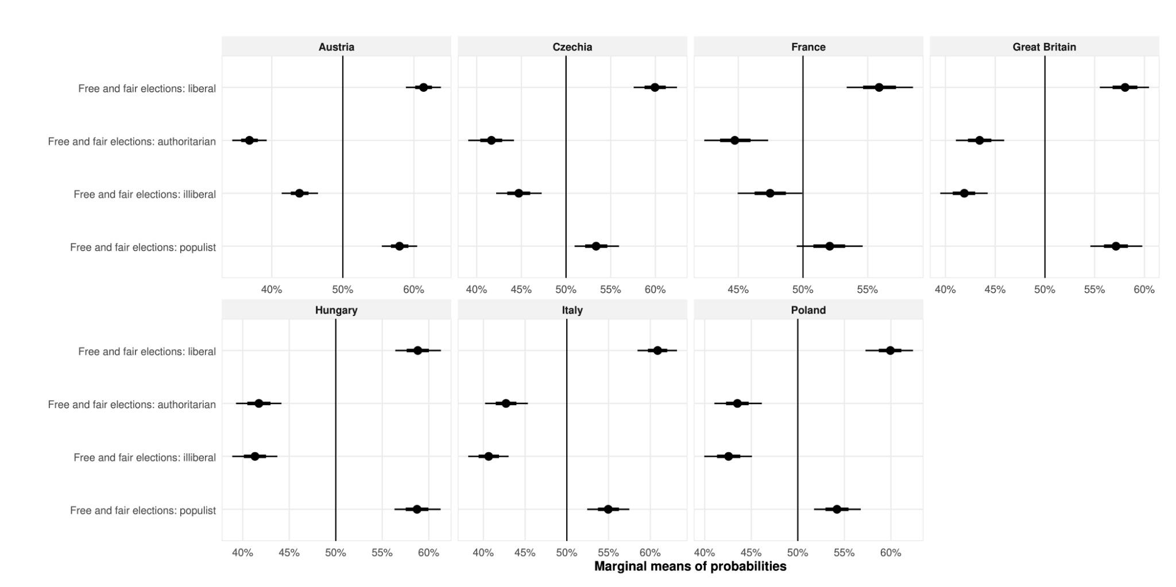

Figure 2 shows the same quantities in the case of civil liberties. In all cases, authoritarian positions on civil liberties are clearly rejected, with candidates punished for holding such views. With the exception of France, where it is rewarded by the electorate, the illiberal position on civil liberties does not have a statistically significant impact on the choice of which party to vote for. At the same time, both populist and liberal positions tend to be rewarded by the electorate. These results lend some support to H1a, in the sense that liberal positions are more likely to be rewarded than populist ones, but with the same caveat that populist positions are often just as popular – and in the case of Austria, more likely than liberal positions to result in a party being chosen. As in the previous case, this also bears out H1b, with populist positions less likely to result in punishment of parties than illiberal or authoritarian positions. In the case of civil liberties, H1c is borne out: parties with an authoritarian stance on this issue are significantly more likely to be punished by the electorate than those with an illiberal position.

Figure 2: *Average marginal mean of probability of choosing a party, conditional on party position on civil liberties.*

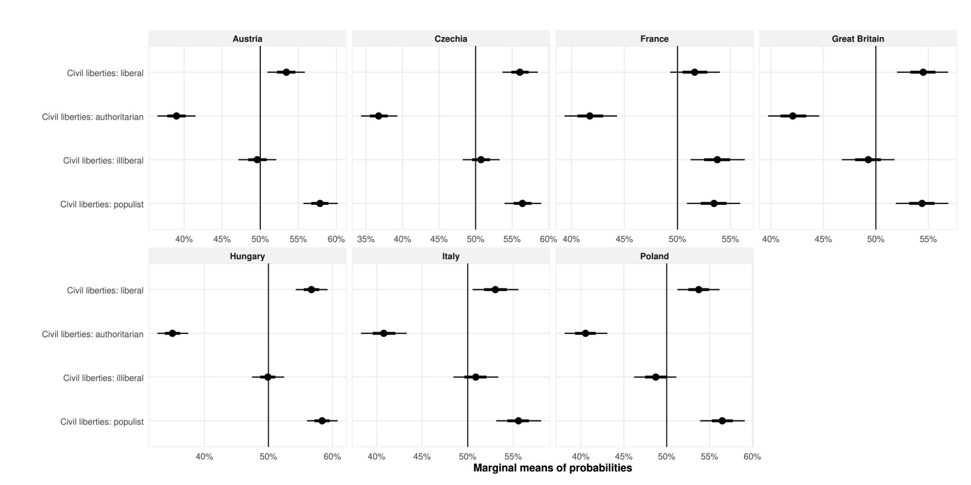

The picture is more mixed in the case of the rule of law. With the exception of Italy, parties with liberal positions on this issue are more likely to be chosen, although not always with greater probability than those with populist positions on the rule of law. Thus the results lend some support to H1a, but do not fully support the hypothesis that liberal positions are preferred to all others. There is no clear support for H1b in the case of the rule of law. While in Hungary parties are less likely to be punished for holding a populist position on the rule of law than they are for holding an illiberal or authoritarian position, in the remaining cases there is no significant difference between populist and illiberal positions. It is also not clear that authoritarian positions are any more likely to be punished than illiberal ones: while this is the case in Austria and Great Britain, in the remaining countries there is little significant difference.

Overall, the results suggest that responses are sufficiently similar across our seven countries of study, particularly with respect to the rejection of authoritarian stances, to warrant the conclusion that the patterns we observe are representative of broad tendencies in consolidated liberal democracies. At the same time, they point to some areas of country-level difference that further research could profitably explore. For the purposes of this paper, however, we will focus on the general patterns.

Figure 3: *Average marginal mean of probability of choosing a candidate, conditional on party position on the rule of law.*

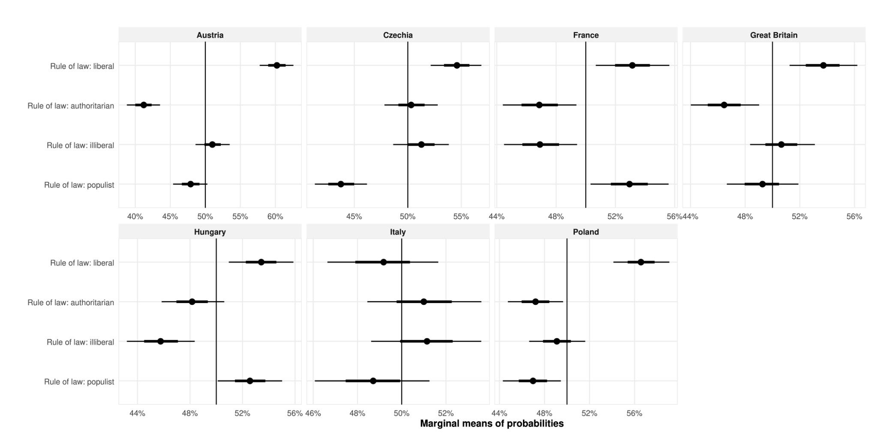

## Political attitudes and their relationship with PIA

Figure 4 shows the average probability of selecting a party given each of the PIA stances in the conjoint choice set, conditional on respondents’ own attitudes to liberal democracy. The effect of liberal stances is derived by calculating predicted probabilities for respondents holding attitudes that are one standard deviation below the mean on the populist, illiberal and authoritarian attitude variables. The effect of anti-liberal (combined populist, illiberal and authoritarian) stances is derived by calculating such probabilities for respondents who are one standard deviation above the mean on each of the three sets of attitudes.

Respondents holding liberal attitudes reward parties for holding liberal positions on free and fair elections, civil liberties and the rule of law. They also tend to punish parties for holding populist, illiberal or authoritarian attitudes on these dimensions. In that sense, H2a is supported. However, if the point of reference is not the 50% threshold for rejection versus support, but the propensity of anti-liberal respondents to punish (or reward) such positions, the picture is a little less clear. While liberal respondents are more likely than their anti-liberal counterparts to *punish* authoritarian and illiberal positions on free and fair elections, they are more likely to *reward* populist stances. On the rule of law, relative to their anti-liberal counterparts, liberal respondents are much more likely to reward a liberal position, and more likely to punish authoritarian, populist and illiberal ones. In the case of civil liberties, liberal respondents are much more likely to reward a liberal position, and much more likely to punish an authoritarian one. However, there is no significant difference in the propensity of liberal and anti-liberal respondents to reward or to punish illiberal or populist positions in the matter of civil liberties.

Figure 4: *Average marginal mean of probability of choosing a party, conditional on party position on the rule of law and level of liberalism among respondents.*

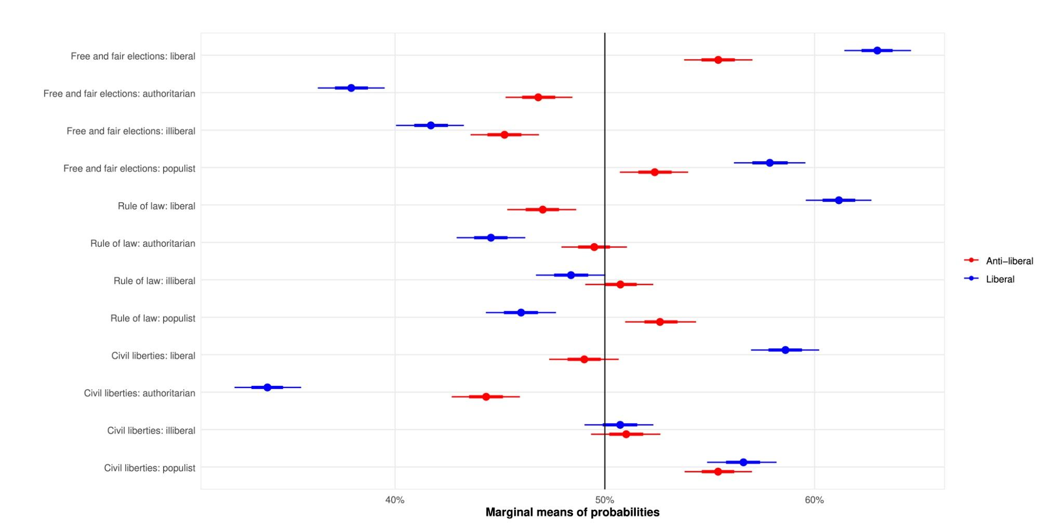

To address H2b, H2c and H2d, we calculate the mean probability of respondents rewarding parties for populist, illiberal, and authoritarian positions respectively, conditional on respondents having populist, illiberal and authoritarian attitudes. A respondent is defined as such if their position on the respective variables is one standard deviation above the mean value. We also calculate probabilities for respondents who have positions two or three standard deviations above the mean to see whether more extreme positions have a stronger impact on choices.

In line with H2b, parties are rewarded by populist-minded respondents for advocating populist views. As Figure 4.2 shows, in each case the median response is to the right of the 50% line, indicating a greater probability of choosing parties proposing populist solutions. While the probability of choosing a party advocating populist positions on the rule of law rises as a respondent becomes more populist, in the case of free and fair elections and civil liberties the differences are not significant.

Figure 5: *Average marginal mean of probability of choosing a party, conditional on populist party positions and level of populism among respondents.*

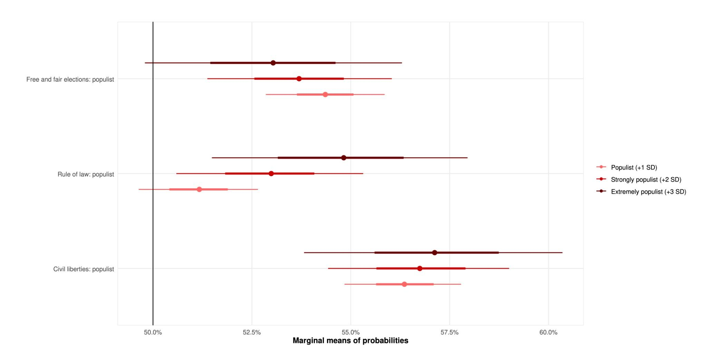

In the case of illiberalism, H2c is partly upheld. Respondents with illiberal views are more likely to vote for parties which have illiberal views on the rule of law and civil liberties. However, they are still more likely to punish parties with illiberal positions on free and fair elections, and even those with extremely illiberal views do not reward parties for holding these views.

Figure 6: *Average marginal mean of probability of choosing a party, conditional on illiberal party positions and level of illiberalism among respondents.*

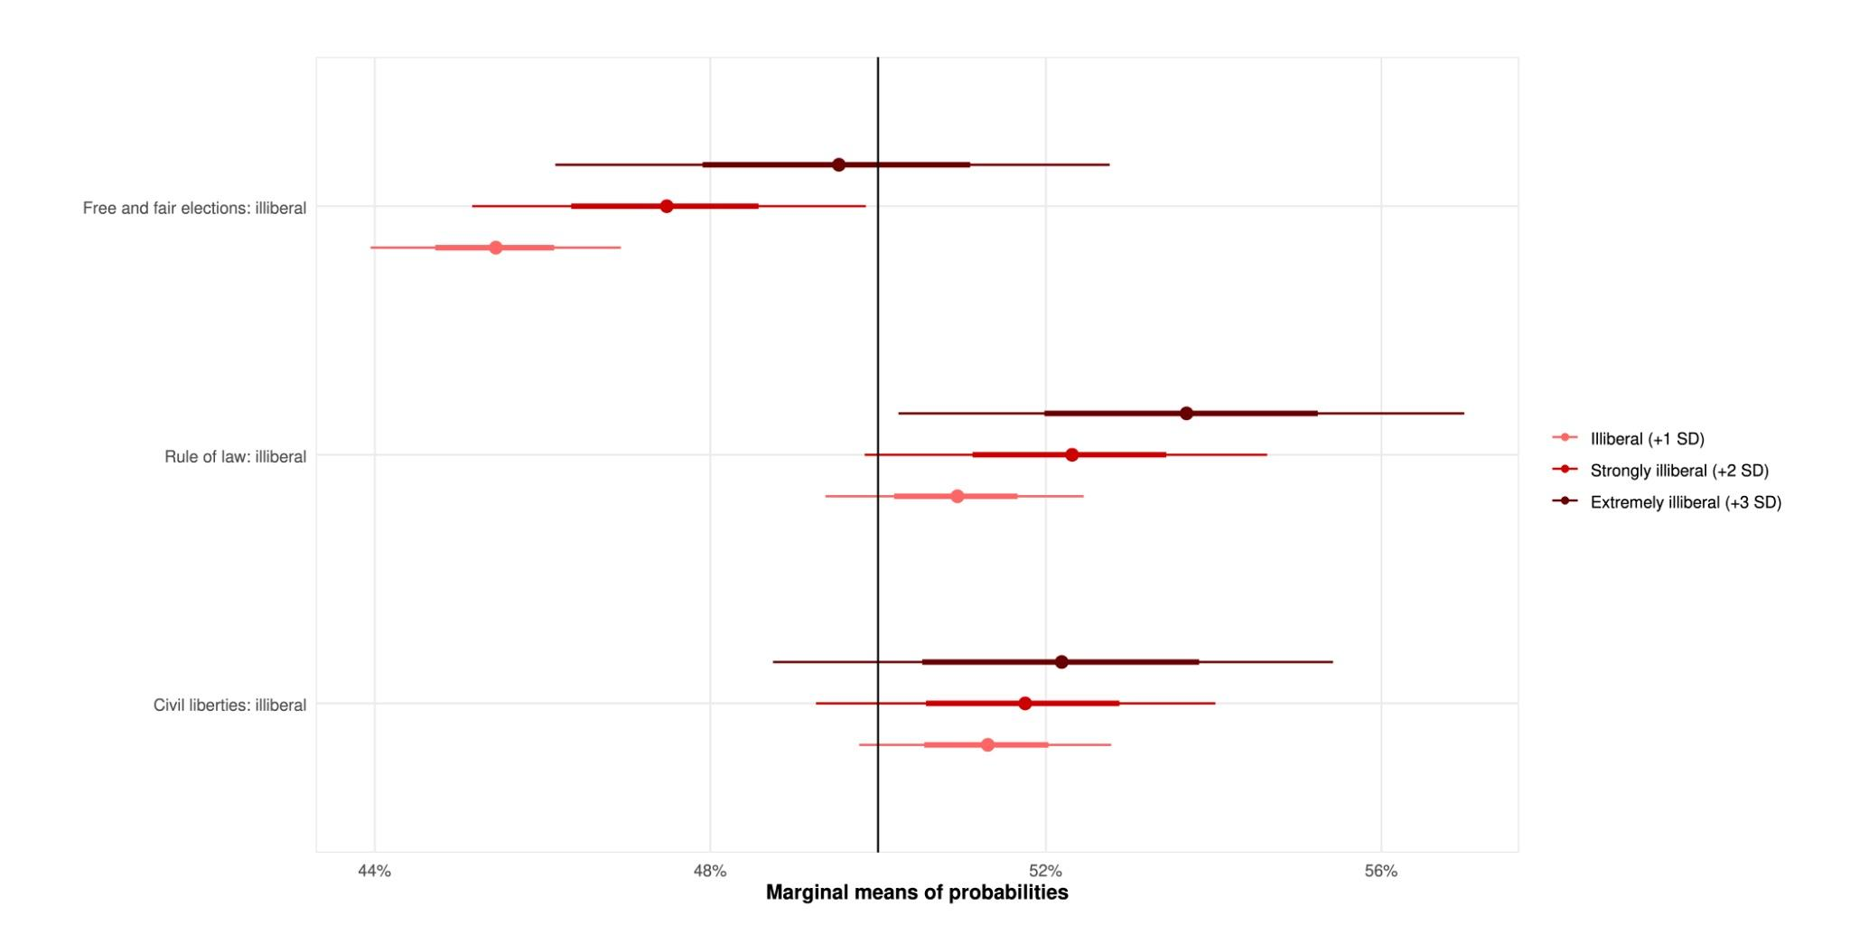

In the case of authoritarianism, much depends on the extent to which those views are held. In line with H2d, those who hold strongly or extremely authoritarian views are more likely to reward parties for authoritarian positions. However, those who are only moderately authoritarian in their views tend to punish parties for holding these views.

Figure 7: *Average marginal mean of probability of choosing a party, conditional on authoritarian party positions and level of authoritarianism among respondents.*

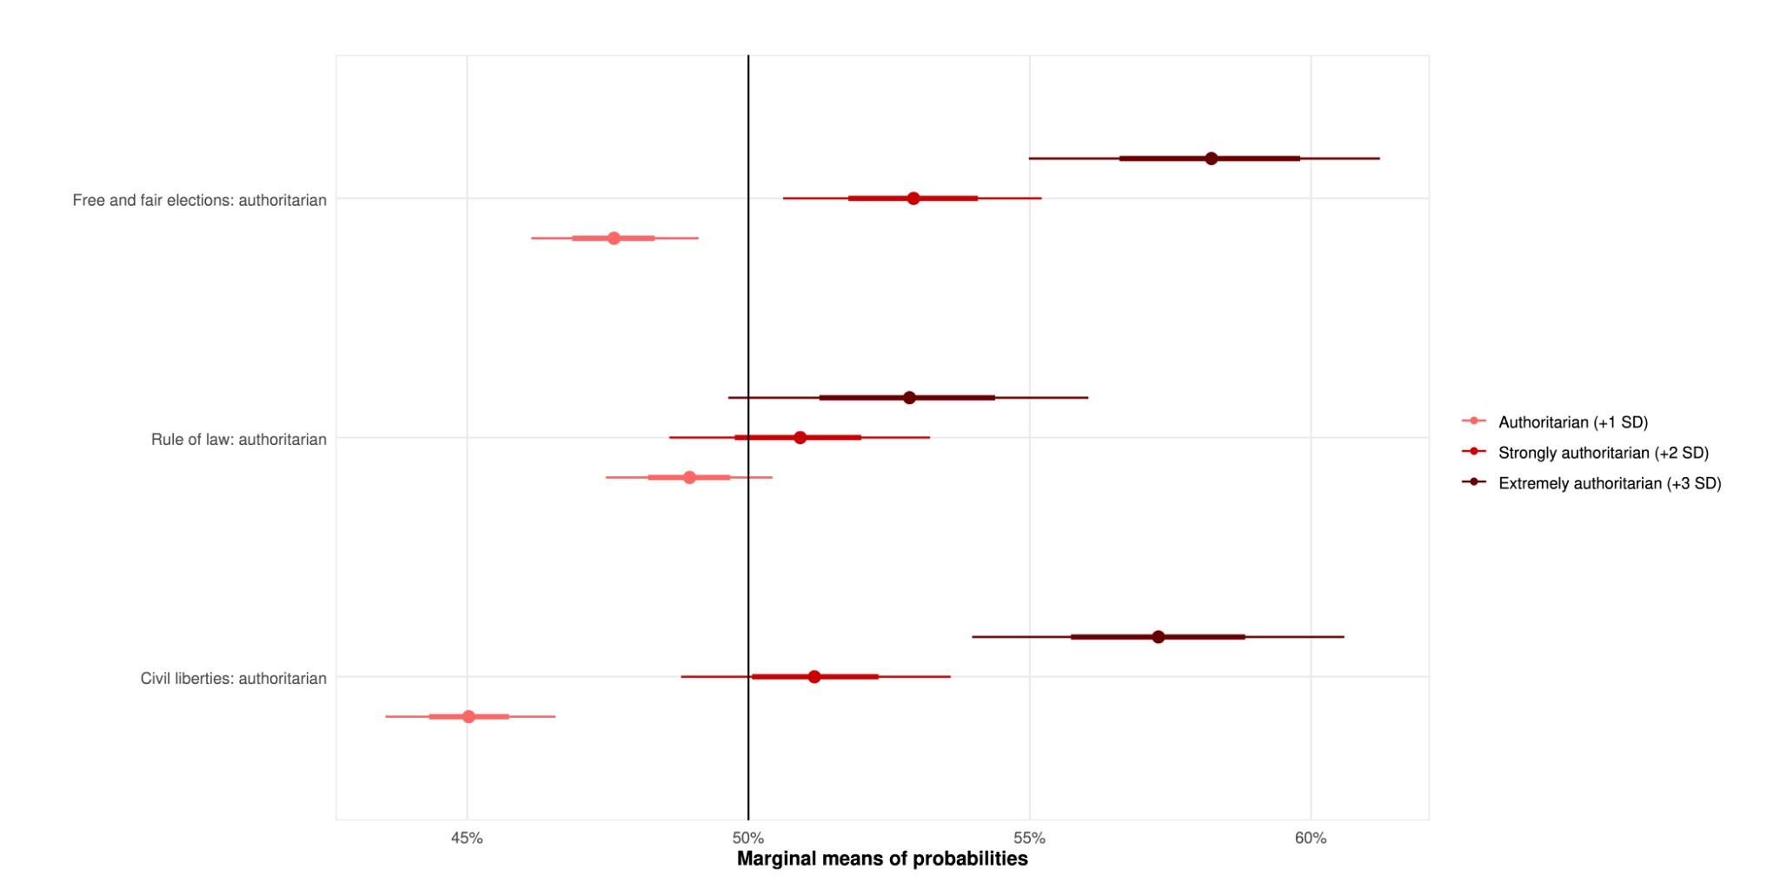

The next set of analyses examines the alignment between the policy positions held by parties and the policy positions held by voters, to determine whether respondents are more likely to reward or punish a political party for expressing PIA views if they are ideologically aligned with that party. To examine this question, we analyse alignment on economic and sociocultural issues.

In the case of economic issues, we use two variables. One is at the level of parties, and measures whether a party is in favour of higher income taxes and extensive social spending (left-wing position), in favour of moderate income taxes and more moderate levels of social spending (centrist position) or in favour of high income taxes and low levels of social spending (right-wing position). The second variable is at the level of individual respondents, and measures attitudes to redistribution, measured by asking respondents to indicate their level of agreement or disagreement with the statement “Governments should reduce differences in income levels”. Given that there is a significant skew in responses to this question, we code strong agreement with the statement as a left-wing position, moderate agreement as a centrist position, and indifference or disagreement as a right-wing position.

Figure 8 plots the probability of respondents choosing a party, given (a) their own attitudes towards redistribution, and (b) the position taken by each party on income tax policy. This requires three separate panels showing how the probabilities vary as individual attitudes change. In the case of those with left-wing views on redistribution, in most cases parties are less likely to be punished (or more likely to be rewarded) for their positions on PIA issues if they also advocate *high* levels of income tax. Conversely, in the case of those with right-wing views on redistribution, parties are more likely to be punished, or less likely to be rewarded, if they advocate *low* levels of income tax.

However, as the results for centrist positions show, there is only partial support for the hypothesis. In most cases, a party is more likely to be rewarded or less likely to be punished for its PIA stances if it takes a *moderate* position on income tax. That general observation holds regardless of whether a respondent has left-wing, centrist, or right-wing views on redistribution. This suggests that the popularity of moderate positions on income tax is sufficient not only to amplify the reward a party gains for its liberal and populist stances, but also to mitigate the punishment it faces for holding illiberal or authoritarian views. Rather than ideological alignment, what seems more important here is ideological distance from the centre: while centrist respondents do not essentially differ in the ways in which they treat left-wing or right-wing parties for their PIA stances, left-wing and right-wing respondents alike are more likely to punish the other side for their PIA positions than they are to punish their own, even as both remain more favourably inclined towards parties which are centrist on the economic dimension.

Figure 8: *Average marginal mean of probability of choosing a party, conditional on PIA party positions, party positions on economic issues, and respondent positions on economic issues.*

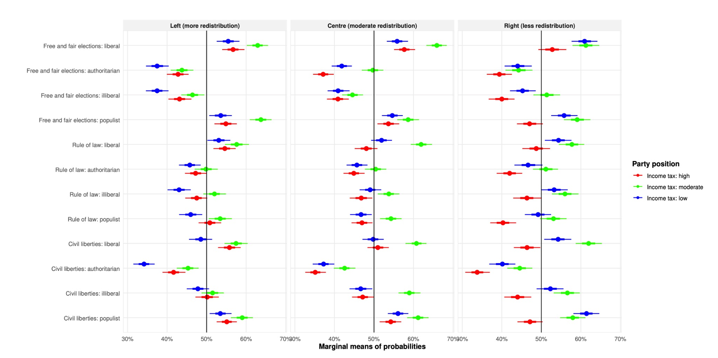

The analysis follows the same essential logic in the case of sociocultural issues. To assess this, we examine the effect of alignment over immigration. At the party level, the left-wing position is of an open approach to immigration regardless of the origin of the immigrant in question, the centrist position is one of support for immigration on the basis of economic reasons, and the right-wing position is one of opposing immigration entirely. To operationalise this, we use the average response to two questions scaled between 0 and 10, one on whether and to what extent immigration is good for the economy or bad for the economy, and one on whether and to what extent immigration undermines or enriches cultural life. As there is a moderate skew in these responses, we recode the variable so that responses from 0 to 3.5 denote right-wing views, responses between 4 and 6 denote centrist views, and responses between 6.5 and 10 denote left-wing views.

Figure 9 plots the results in the same fashion. Among respondents who hold left-wing views, there is a very clear set of differences. If a party holds right-wing views on immigration, it is always punished on every PIA measure, and only in the case of a liberal policy on free and fair elections are left-wing respondents even slightly more likely to choose this party. In the case of left-wing and centrist positions on immigration, in most cases left-wing voters are more likely to support a party regardless of its stance on PIA issues. The only exceptions are authoritarian or illiberal positions on free and fair elections, and authoritarian positions on civil liberties, where parties are punished regardless of their left-wing views on immigration.

In the case of respondents holding right-wing positions on immigration, we see a clear propensity to punish parties for a left-wing position on immigration, regardless of whether they hold PIA or liberal stances on questions of democracy. Conversely, even authoritarian positions on free and fair elections or civil liberties are forgiven by respondents holding right-wing views on immigration if the party in question supports immigration only for economic reasons, or rejects immigration altogether.

Among voters with centrist views on immigration, the moderate policy of economic immigration is more likely to encourage voting for a party regardless of its PIA stances. While the picture is mixed in the case of right-wing immigration policy, in all cases candidates are punished by centrist voters for having an open-door immigration stance, regardless of whether they hold PIA or liberal positions on democracy. Thus the conclusion is similar: while in the case of immigration left-wing respondents are more likely to punish right-wing parties and reward left-wing ones, and vice versa in the case of right-wing respondents, a moderate policy on immigration is likely to outweigh concerns voters may have about its democratic credentials, regardless of the respondent’s own attitude to immigration.

Figure 9: *Average marginal mean of probability of choosing a party, conditional on PIA party positions, party positions on sociocultural issues, and respondent positions on sociocultural issues.*

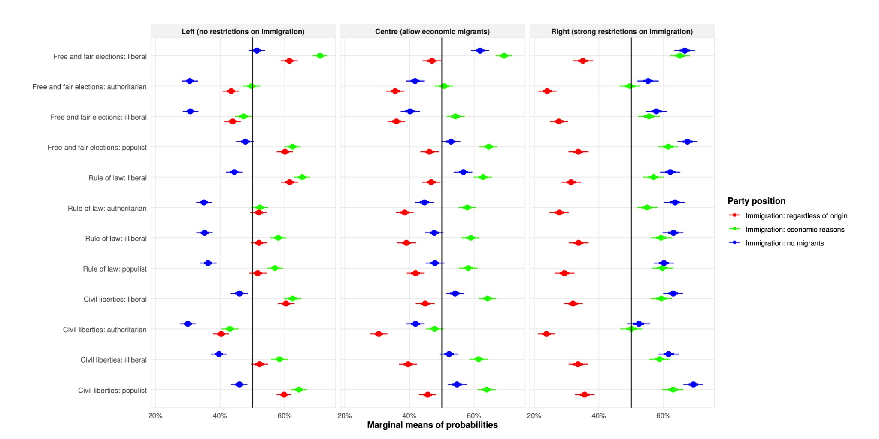

## 

## Socio-demographic characteristics and their relationship with PIA

The final set of analyses concerns the relationship between the socio-demographic characteristics of respondents and their propensity to punish or reward parties for their positions on democracy.

According to H4a, we should expect to see that young people (those less than 30 years of age) are less likely than their older counterparts to punish parties for holding populist, illiberal or authoritarian views. However, as Figure 9 shows, there is no consistent pattern. In most cases, there is no statistically significant difference between younger and older cohorts.

The same is true in the case of gender, as illustrated in Figure 10. While we expected men to be less likely to punish parties for holding PIA views, this is only the case when it comes to authoritarian positions on the rule of law, and indeed men are less likely than women to punish parties for advocating illiberal approaches to free and fair elections.

Figure 9: *Average marginal mean of probability of choosing a party, conditional on PIA party positions and respondent’s age.*

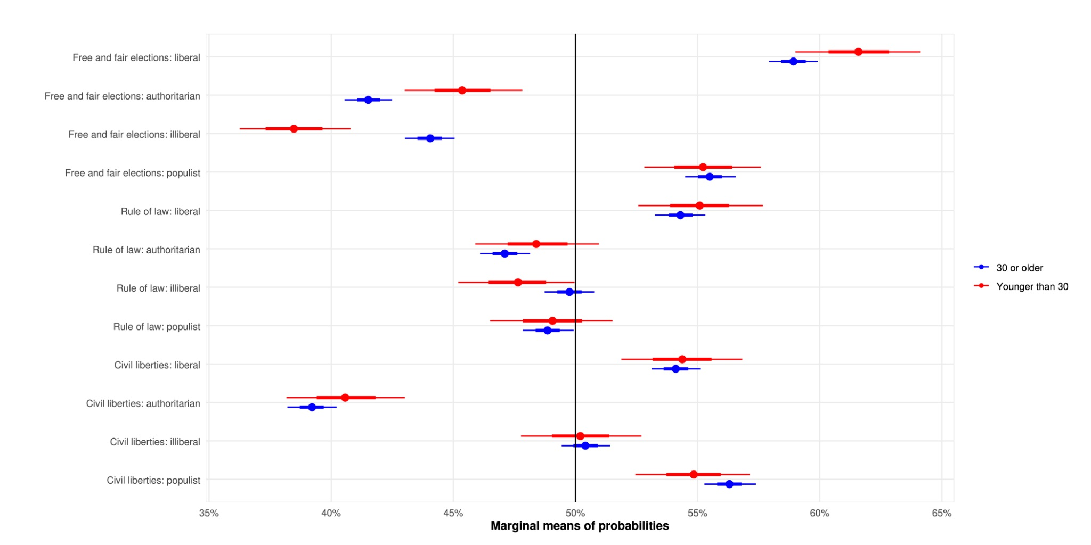

Figure 10: *Average marginal mean of probability of choosing a party, conditional on PIA party positions and respondent’s gender.*

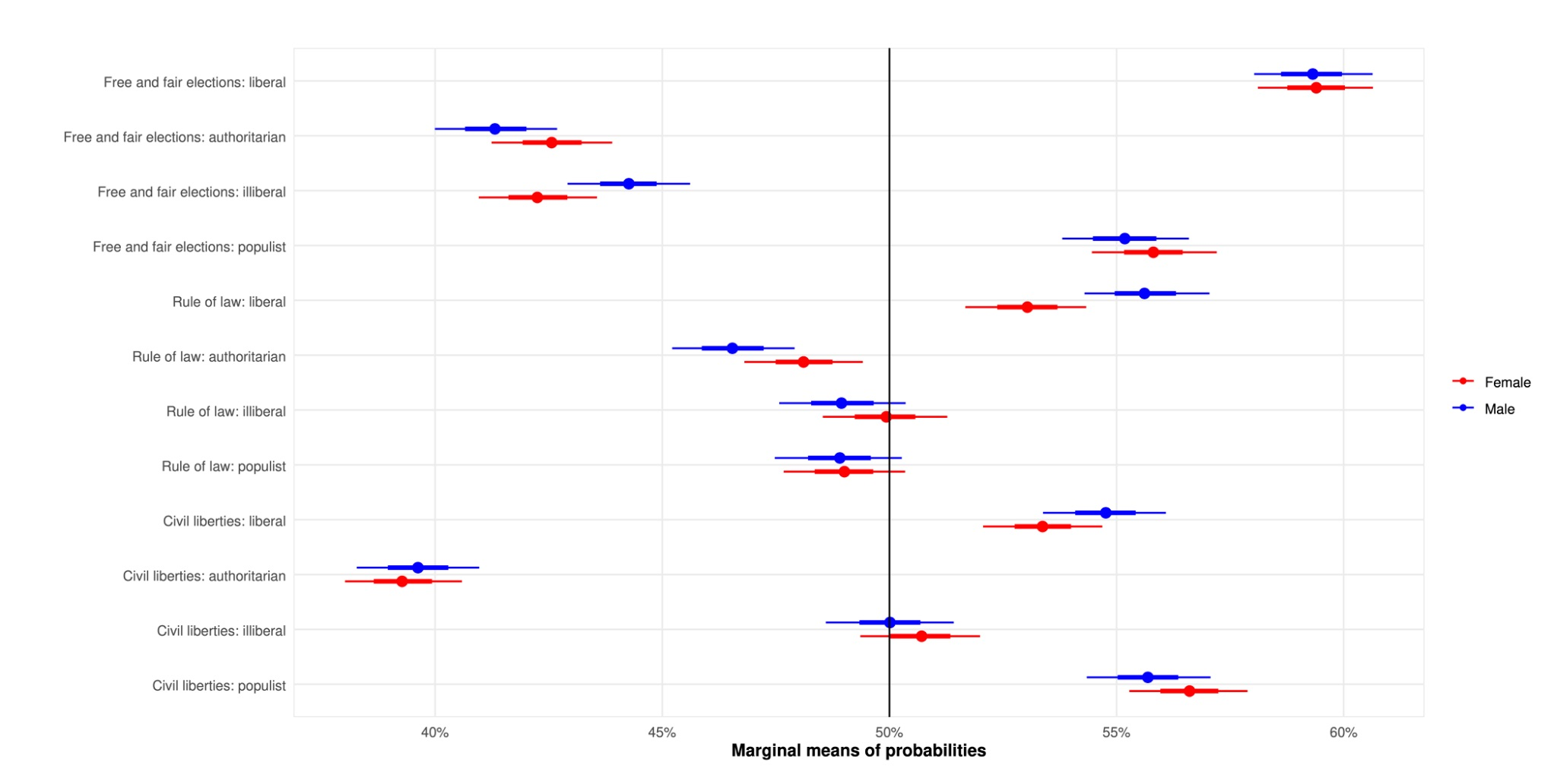

Aside from the two for which we had preregistered hypotheses, we also investigate whether there are any differences in the cases of other typically significant socio-demographic categories.

Figure 11 shows the probability of choosing a party, conditional on PIA and whether a respondent has primary, secondary or tertiary education. There are some noteworthy differences. Where free and fair elections are concerned, respondents with primary education are less likely to punish parties for advocating an authoritarian solution, but less likely than those with tertiary education to reward them for holding liberal or populist ideas. They are also more ambivalent about the rule of law, being less likely to reward a party for a liberal stance on this issue. On civil liberties, they are less likely than those with tertiary education to support parties that have a liberal position, and less likely to punish those who have authoritarian views.

Figure 11: *Average marginal mean of probability of choosing a party, conditional on PIA party positions and respondent’s level of education.*

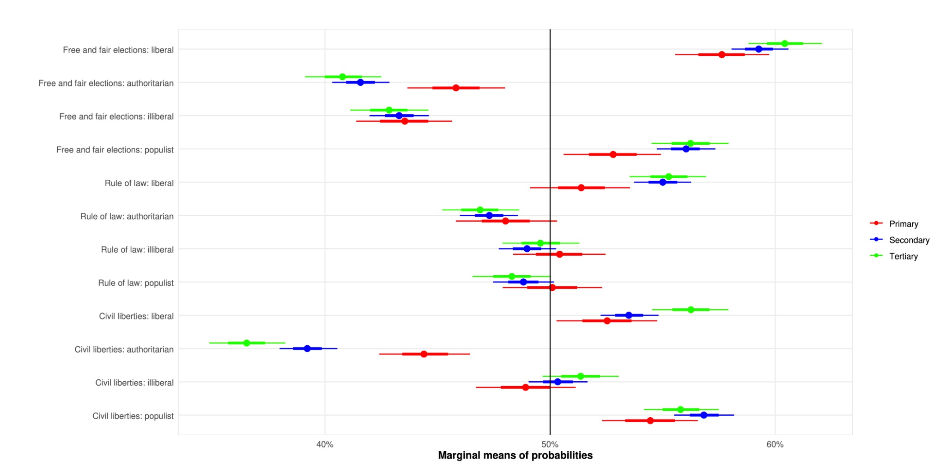

There are few significant differences when it comes to place of domicile. Those who live in cities are more likely than those who live in rural areas to choose parties which espouse liberal positions on free and fair elections and the rule of law, but the propensity to punish or reward parties for PIA positions does not significantly vary.

Figure 12: *Average marginal mean of probability of choosing a party, conditional on PIA party positions and respondent’s place of domicile.*

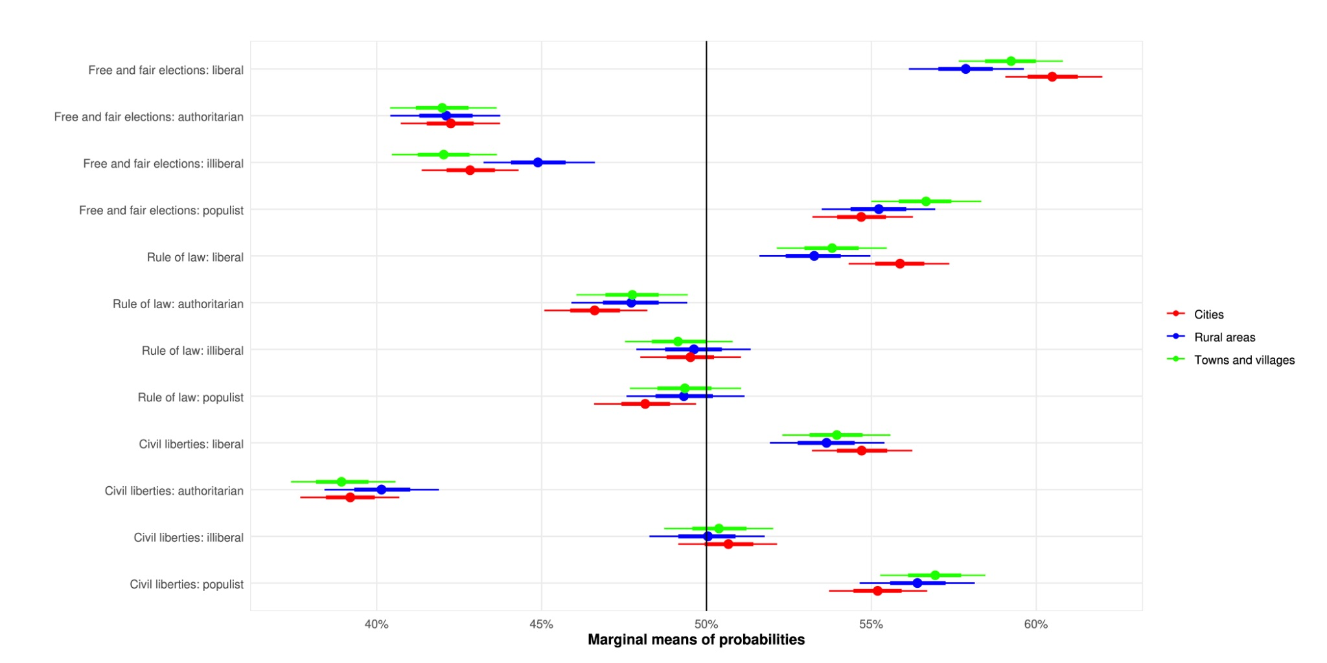

Respondents who attend religious services at least once a month are more likely than those who less regularly attend to reward parties that hold liberal positions on free and fair elections and on the rule of law, while they are more likely to punish authoritarian views on free and fair elections, and illiberal views on the rule of law.

Figure 13: *Average marginal mean of probability of choosing a party, conditional on PIA party positions and respondent’s level of religious participation.*

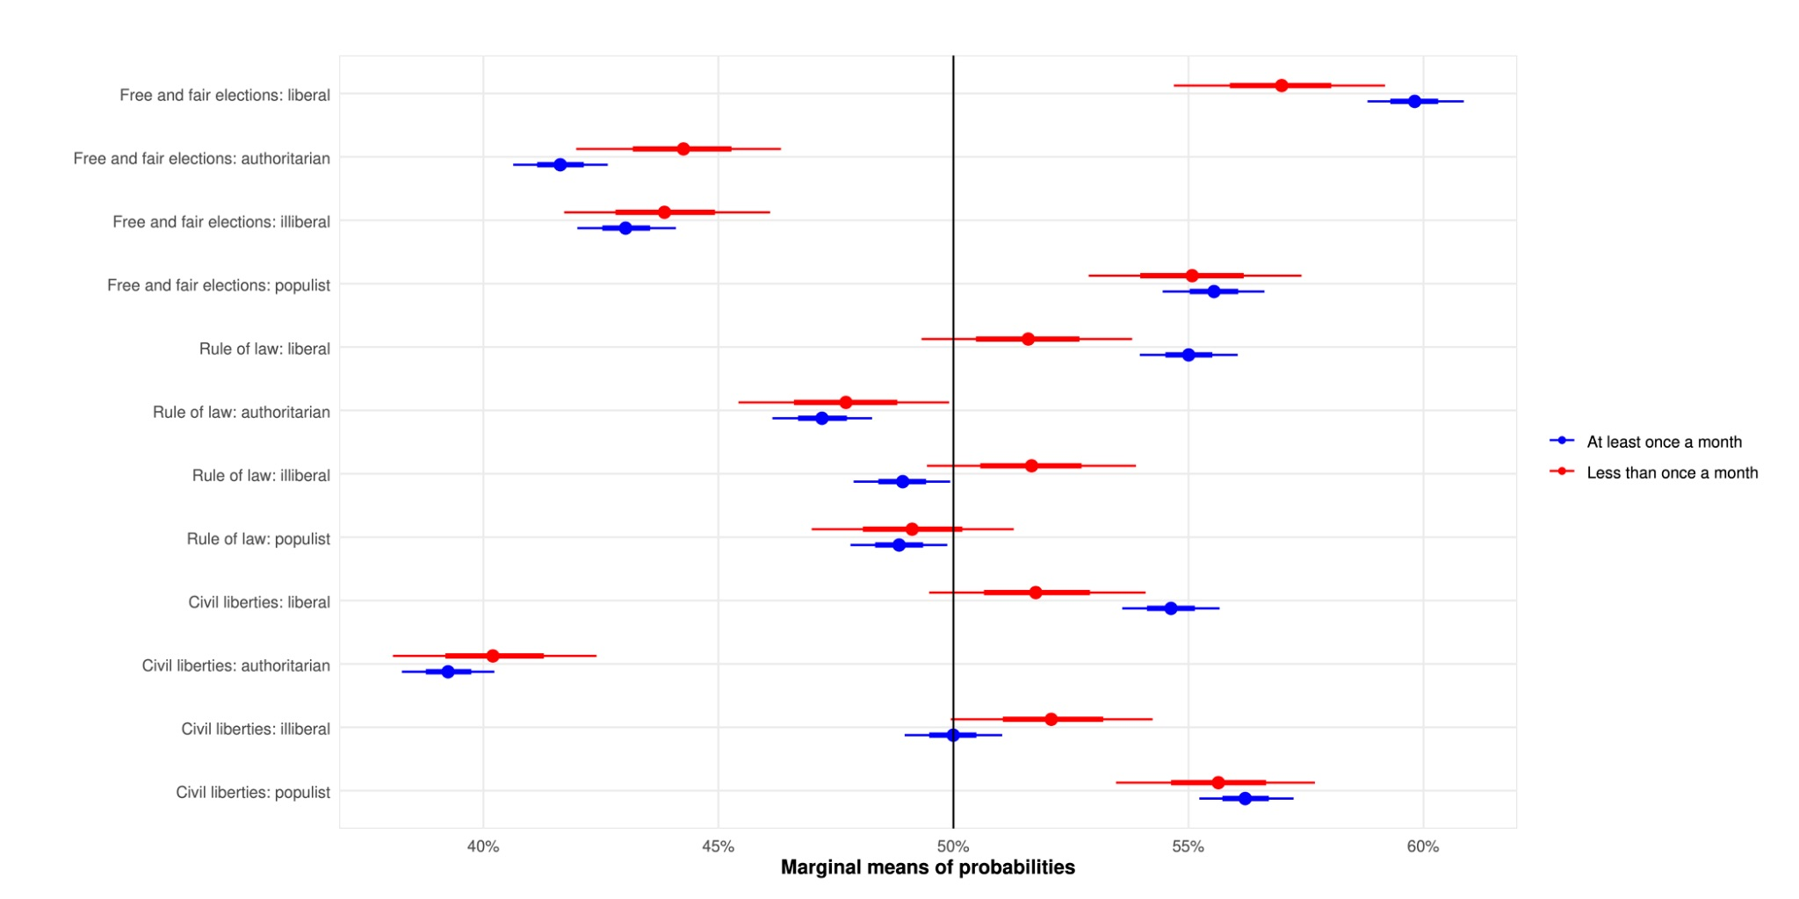

# Conclusion

In this paper we have reported the results of conjoint analyses, addressing the extent to which voters reward or punish political parties based on their support and diverse oppositions to liberal democratic principles. We focused on three core principles of democracy – free and fair elections, the rule of law, and civil liberties. For each democratic principle we devised liberal, populist, illiberal, and authoritarian party positions, allowing us to measure voter responses to these positions. Furthermore, our hypothetical parties also took stances on economic and immigration issues, enabling us to assess how voters respond to various oppositions to democracy when they are cross-pressured – when the democratic offenders simultaneously hold economic or immigration positions that the voters agree with. Our design thus allowed us to measure voter responses to diverse anti-democratic propositions, while considering party positions on other salient issues in interaction with voter preferences and socio-demographic characteristics.

Our article provides three fundamental findings. First, voters are not indifferent to the democratic positions of political parties. Despite some cross-national variation, voters tend to generally prefer liberal democratic positions, and punish illiberal and especially authoritarian positions of parties, all else equal. Interestingly, in the case of free and fair elections, and civil liberties, voters are more permissive of populist party positions, suggesting that many view populist principles as acceptable in contemporary European democracies.

Our second finding suggests that socio-demographic characteristics of voters do not matter much for how voters respond to the democratic credentials of parties. We do find, for example, that more educated voters are more likely to support parties with liberal stances, and more likely to punish authoritarian ones, but these effects are relatively small, and significant only for some democratic principles. Overall, and contrary to our expectations, women and men, younger and older voters, more or less educated or religious, from larger or smaller settlements, do not differ very significantly in their appraisal of democratic party credentials.

Our final, and most important finding, is the central importance of voters’ views on specific policy issues as the determinant of electoral choice, and their willingness to discount democratic transgressions when key policies are being served. On economic issues, voters tend to moderately punish political parties that hold opposite economic positions to theirs, while being relatively supportive of parties that hold centrist economic positions. Interestingly, on economic issues, cross-pressured voters — voters of parties that hold their positions on economic issues, but propose illiberal or authoritarian principles — do not generally forego democracy for their preferred economic policy.

This is quite different when we consider party positions on immigration. Voters opposed to immigration are willing to support parties that share their immigration stances regardless of party positions on democracy. Put differently, voters opposed to immigration systematically discount all forms of undemocratic party proposals (with the one exception of authoritarian views on civil liberties), as long as the party promises to cut immigration. Pro-migrant voters tend to prefer parties that share their immigration views, but are generally not willing to support pro-migration parties if they also propose illiberal or authoritarian views. This finding highlights the centrality of immigration as a particularly salient issue to some voters, who are effectively willing to sacrifice central principles of democracy, as long as they can obtain their preferred outcomes on the question of immigration.

# References

Alizada N, Cole R, Gastaldi L, et al. (2021). Democracy report 2021: autocratization turns viral. University of Gothenburg: V-Dem Institute.

Coffe H, Fraile M, Alexander A, Fortin-Rittberger J and Banducci S. (2023). “Masculinity, sexism and populist radical right support.” *Front. Polit. Sci.* 5:1038659. doi: 10.3389/fpos.2023.1038659

Foa, R. S., and Y. Mounk. (2019). “Youth and the Populist Wave.” *Philosophy & Social Criticism* 45 (9–10):1013–1024. doi:10.1177/0191453719872314.

Gwiazda, A. (2021). “Right-wing populism and feminist politics: The case of Law and Justice in Poland.” *International Political Science Review*, 42(5), 580-595. https://doi.org/10.1177/0192512120948917

Neuner, F.G., and Wratil, C. (2022). “The Populist Marketplace: Unpacking the Role of “Thin” and “Thick” Ideology.” *Political Behavior* 44, 551–574.<https://doi.org/10.1007/s11109-020-09629-y>

Svolik, M.W., Avramovska, E., Lutz, J., and Milačić, F. (2023). “In Europe, Democracy Erodes from the Right.” *Journal of Democracy 34*(1), 5-20. doi:10.1353/jod.2023.0000.

Wunsch, N., & Gessler, T. (2023). Who tolerates democratic backsliding? A mosaic approach to voters’ responses to authoritarian leadership in Hungary. *Democratization*, *30*(5), 914–937.<https://doi.org/10.1080/13510347.2023.2203918>

Zagórski, P., Roch, J., Tudó-Cisquella, J., López-Yagüe, A., & Cordero, G. (2024). Generation Z: pessimistic and populist? A conjoint experiment on the determinants of populist voting in Spain. *European Political Science Review*, 1–19. doi:10.1017/S1755773924000237

1. We use “anti-liberal” throughout to denote ideas, parties or movements that are in one way or another opposed to the fundamental norms and institutions of liberal democracy.
2. The hypotheses gathered in this section form part of the pre-registered analysis plan (https://osf.io/hfyav).
3. In this paper we use the term “punished” to refer to a situation when a party receives lower support as a result of a given policy position than it would otherwise have obtained, and “rewarded” to refer to a situation in which a party receives a higher level of support than it would otherwise have obtained.
4. As the analysis is undertaken within a Bayesian framework, these credible intervals mean that given the data we have collected, there is a 66% chance that the true mean would fall between the narrower intervals (denoted by a thicker line on the plot) and a 95% chance that it would fall between the wider intervals (denoted by a thinner line on the plot).